**Installation Instructions**

1. **Unzip Project**

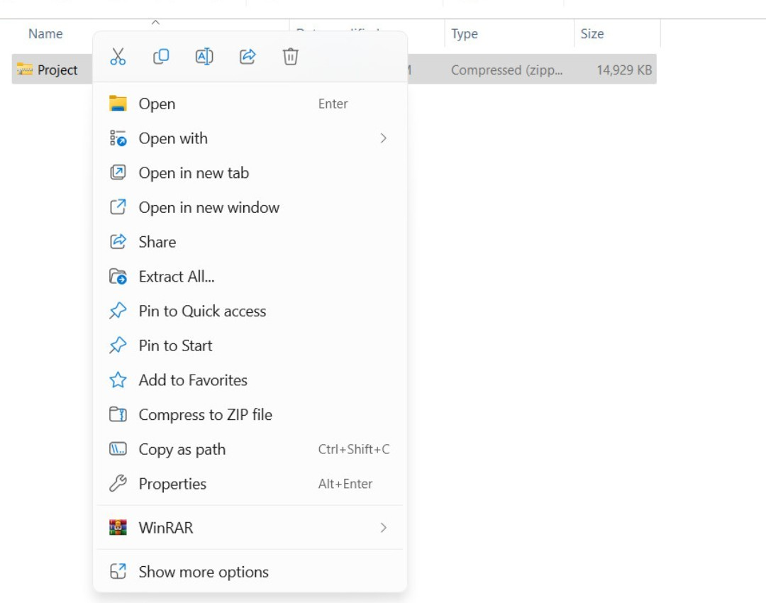

-Right click on Project then select Extract All…

1. **Import Database**

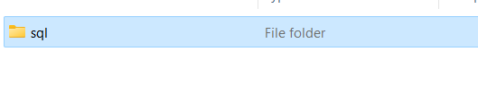

-Go to the sql folder then copy the 2 files in the folder:

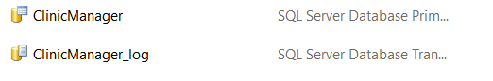

Then we go to disk C, select Program Files -- > Microsoft SQL Server -- > MSSQL16.MSSQLSERVER -- > MSSQL

--> DATA. Then we paste the 2 files we just copied.

1. **Open Project**

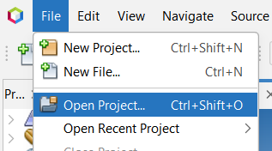

-Open NetBeans, then select the file and select Open Project.

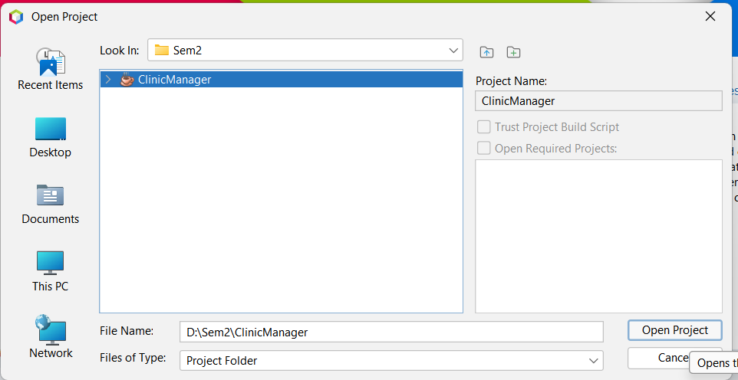

-Select the path to the ClicnicManager folder then select Open Project

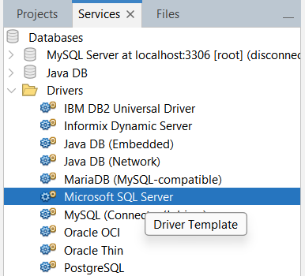

-Then go to Services -- >Drivers -- > Microsoft SQL Server.

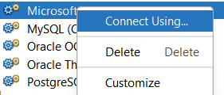

- Right-click and select Connect Using…

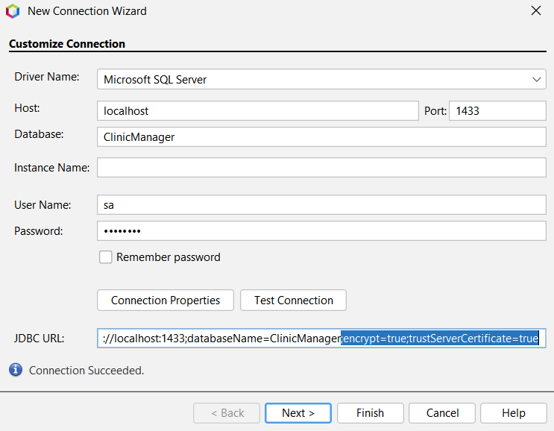

We enter data as follows:

-Database: ClinicManager.

-User Name and Password are your Microsoft SQL Server login name and password.

-Then we paste ";encrypt=true;trustServerCertificate=true" into the JDBC URL section.

-Then we choose Test Connection. If Connection Succeeded, we choose Finish.

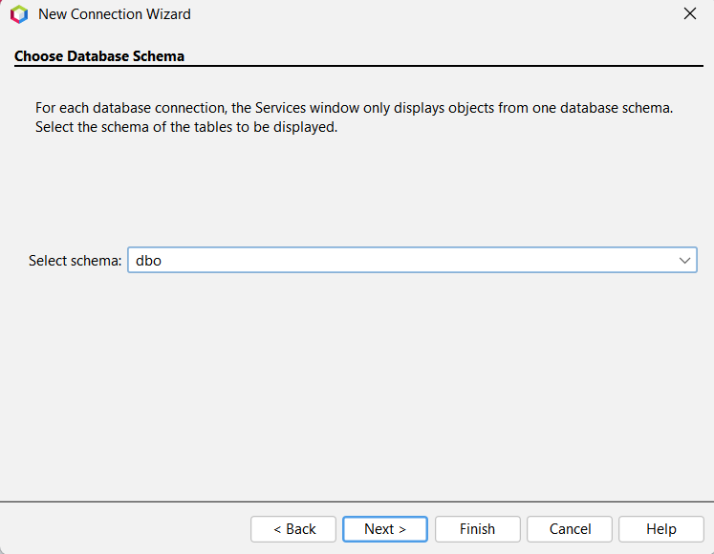

-At Select schema, we choose bdo then select next.

**The end.**